LAB 4

Task 1:

SELECT UPPER(airline_name) AS airline_name_uppercase

FROM airline;

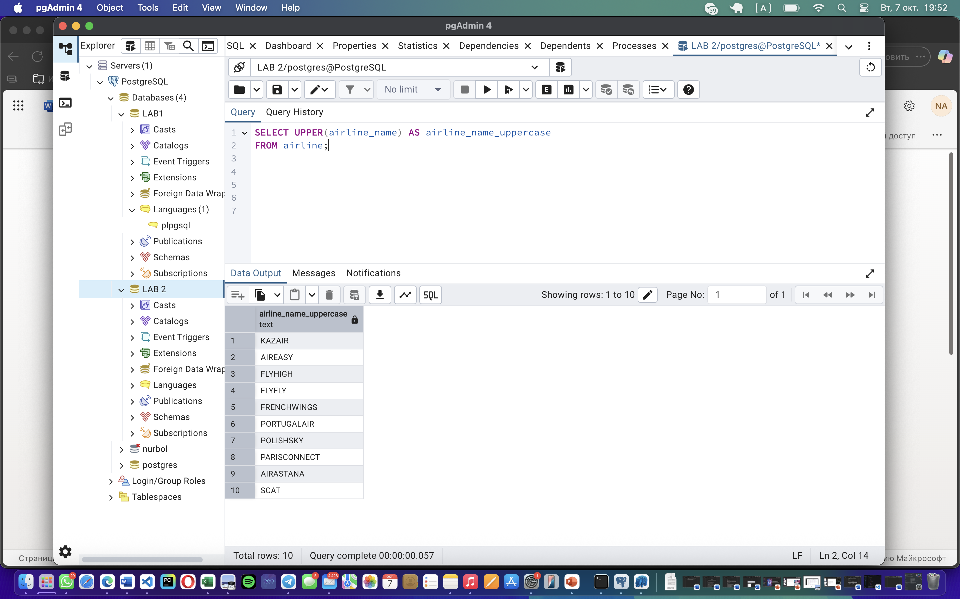

Task 2:

SELECT

REPLACE(airline_name, 'Air', 'Aero') AS modified_airline_name

FROM airline;

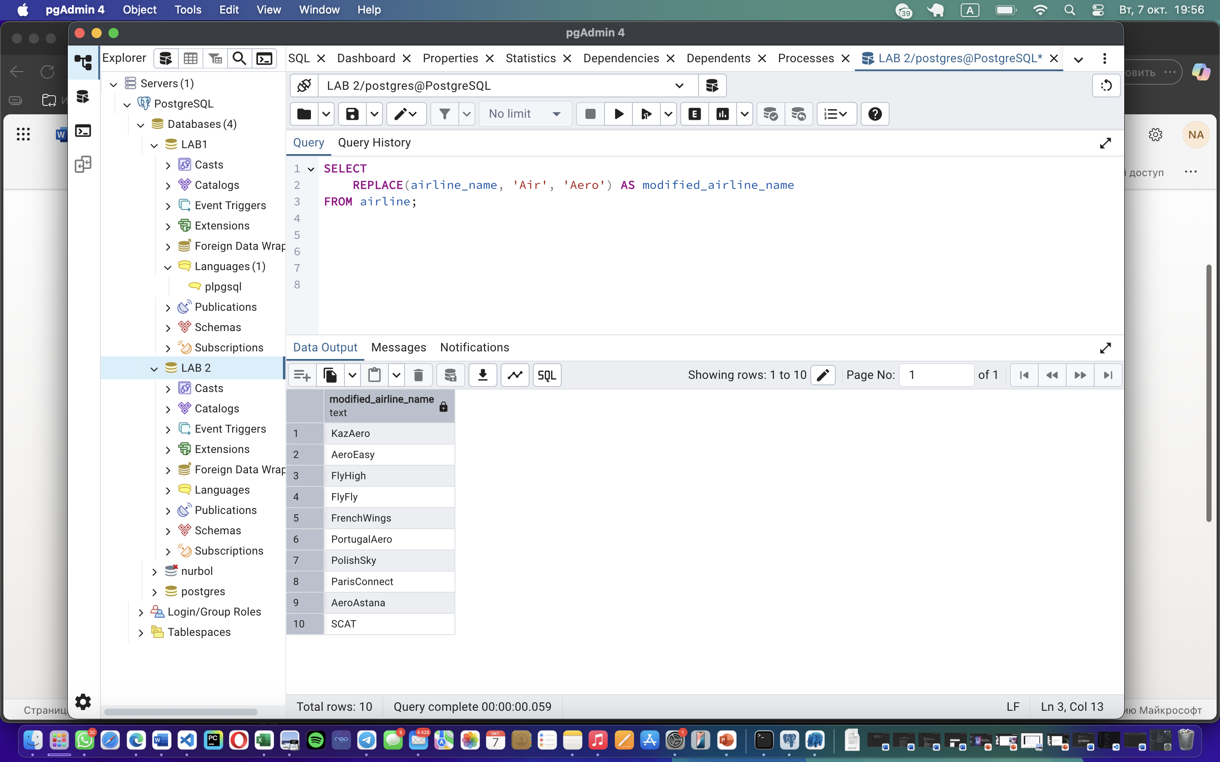

Task 3:

SELECT

f1.flight_id AS airline1_flight_id,

f2.flight_id AS airline2_flight_id,

f1.departing_airport_id,

f1.arriving_airport_id

FROM Flights f1

JOIN Flights f2

ON f1.departing_airport_id = f2.departing_airport_id

AND f1.arriving_airport_id = f2.arriving_airport_id

WHERE f1.airline_id = 1

AND f2.airline_id = 2;

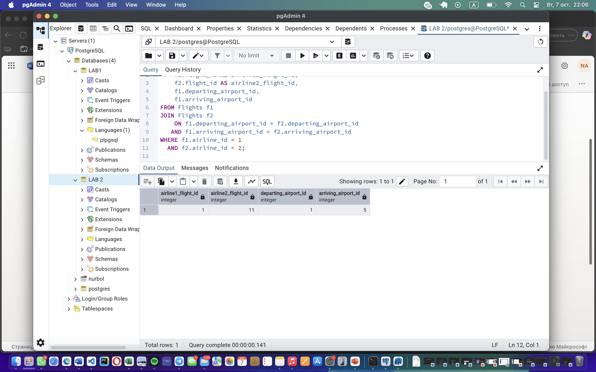

Task 4:

SELECT *

FROM Airline

WHERE airline_name LIKE '%Reginal%'

AND airline_name LIKE '%Air%';

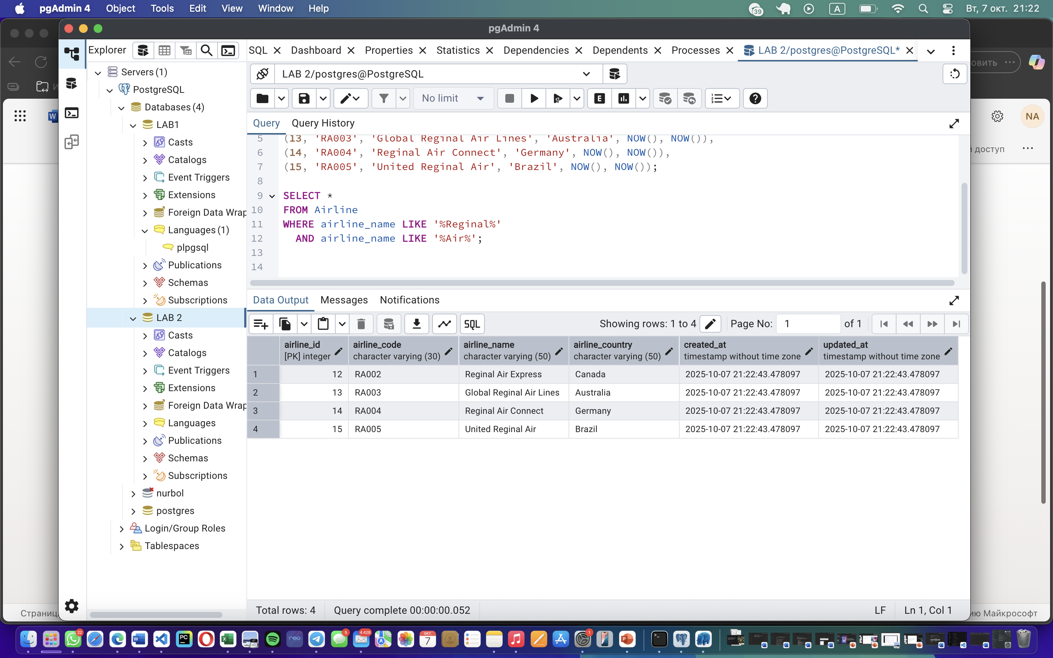

Task 5:

SELECT

CONCAT(first_name, ' ', last_name) AS passenger_name,

TO_CHAR(date_of_birth, 'Month DD, YYYY') AS formatted_birth_date

FROM

passengers

ORDER BY passenger_id;

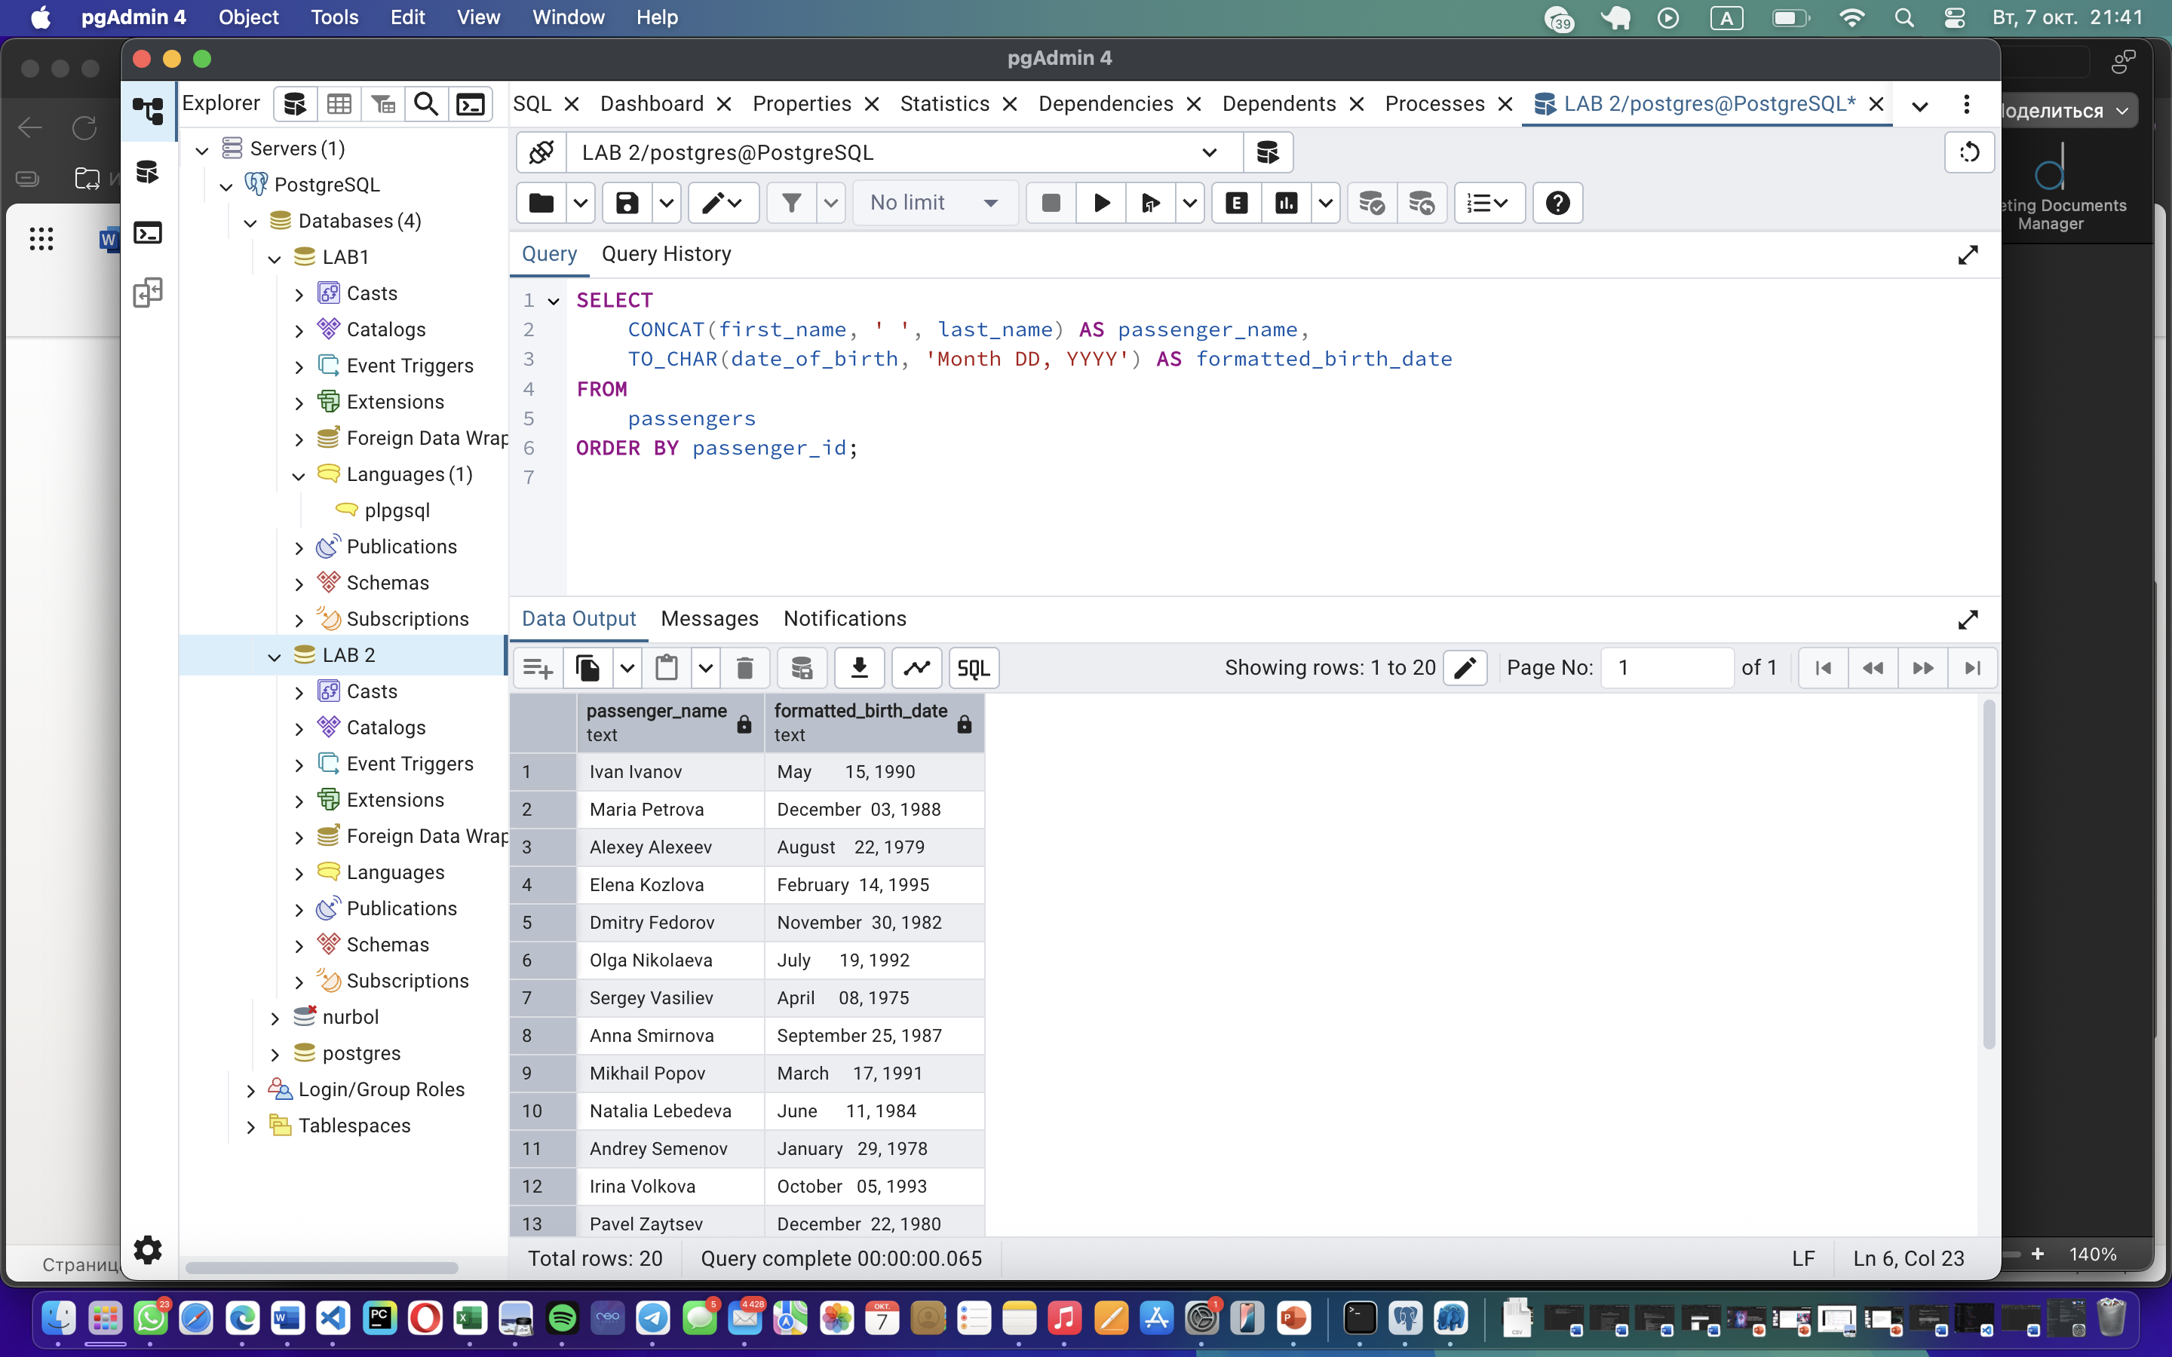

Task 6:

SELECT

flight_id AS flight_number,

sch_arrival_time AS scheduled_arrival_time,

act_arrival_time AS actual_arrival_time,

(act_arrival_time - sch_arrival_time) AS delay_duration

FROM

flights

WHERE

act_arrival_time > sch_arrival_time

ORDER BY

delay_duration DESC;

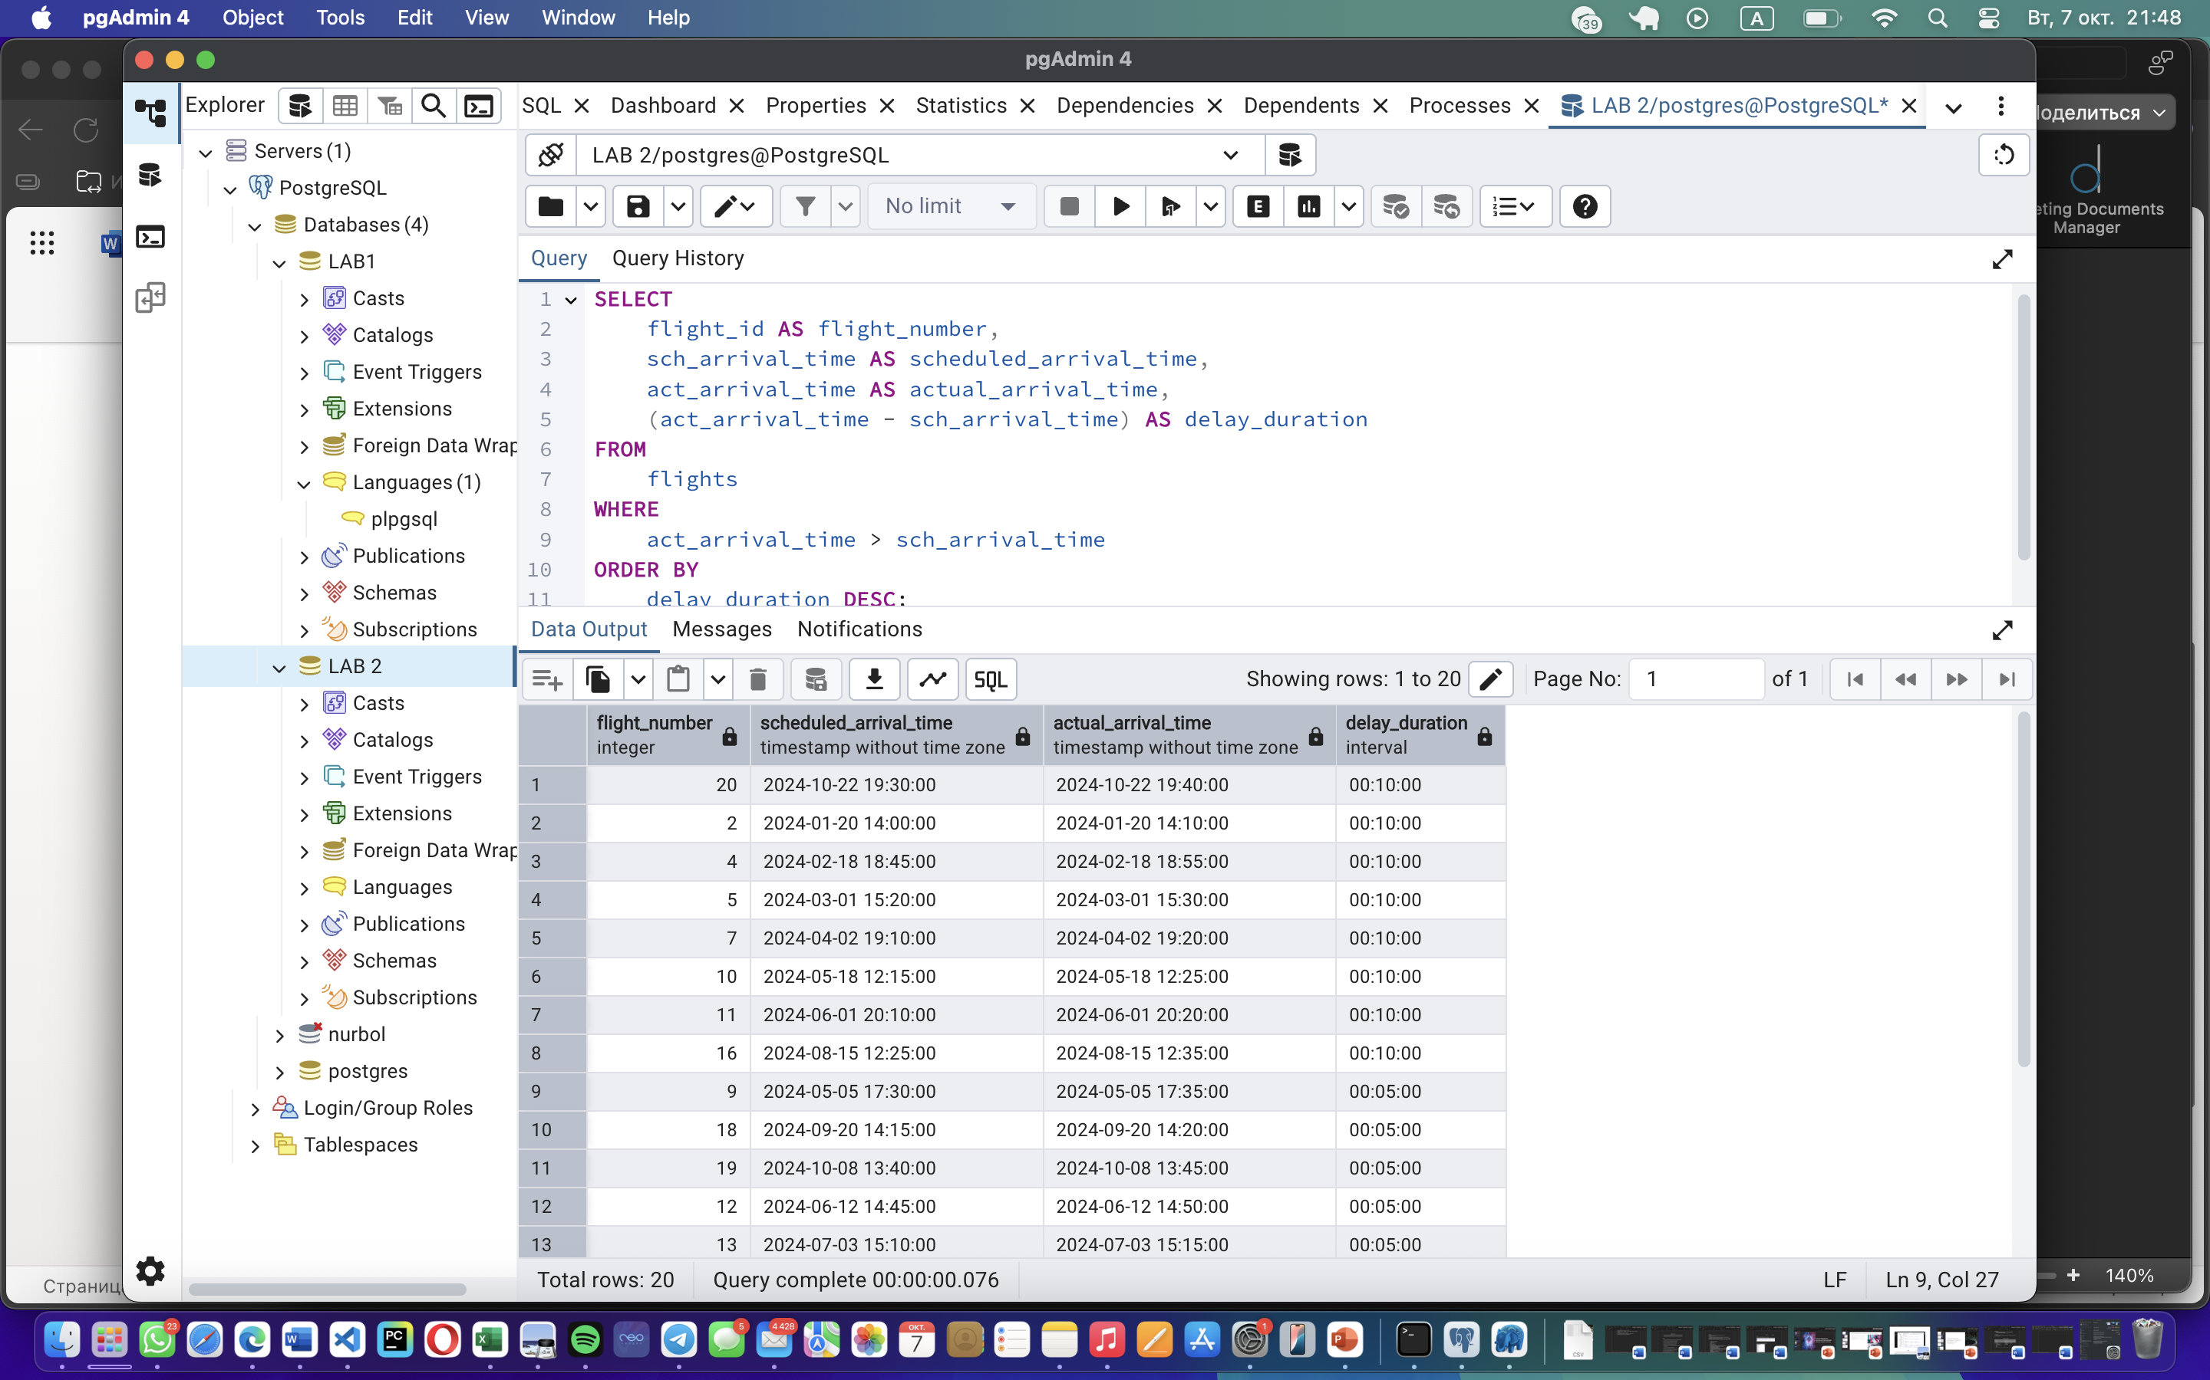

Task 7:

SELECT

passenger_id,

first_name || ' ' || last_name AS passenger_name,

date_of_birth,

EXTRACT(YEAR FROM AGE(CURRENT_DATE, date_of_birth)) AS age,

CASE

WHEN EXTRACT(YEAR FROM AGE(CURRENT_DATE, date_of_birth)) BETWEEN 18 AND 35 THEN 'Young'

WHEN EXTRACT(YEAR FROM AGE(CURRENT_DATE, date_of_birth)) BETWEEN 36 AND 55 THEN 'Adult'

ELSE 'Other'

END AS age_group

FROM

passengers

ORDER BY

age;

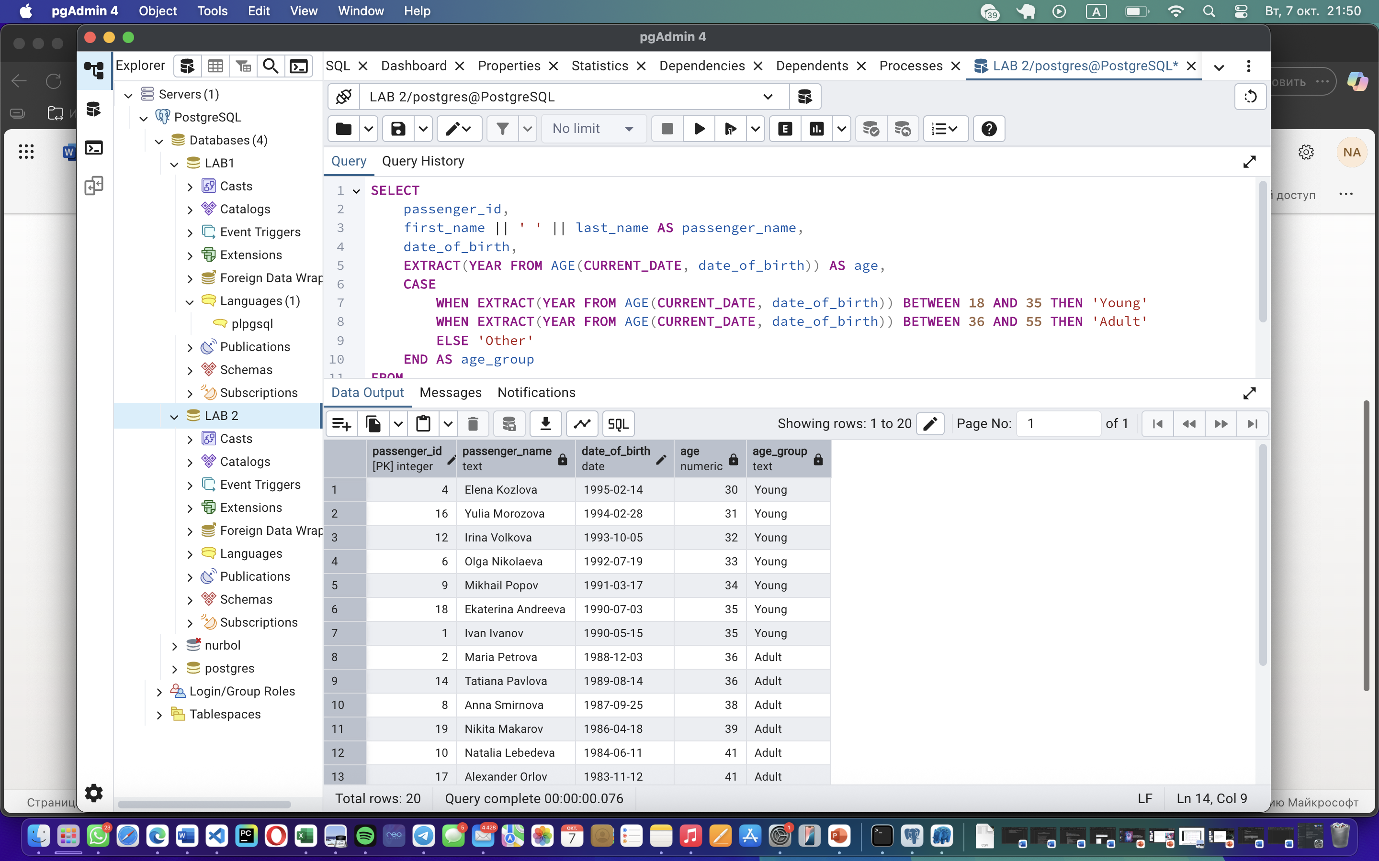

Task 8:

SELECT

ticket_id,

flight_number,

price,

class,

CASE

WHEN price < 15000 THEN 'Cheap'

WHEN price BETWEEN 15000 AND 25000 THEN 'Medium'

WHEN price > 25000 THEN 'Expensive'

ELSE 'Unknown'

END AS price_category

FROM

tickets

ORDER BY

price;

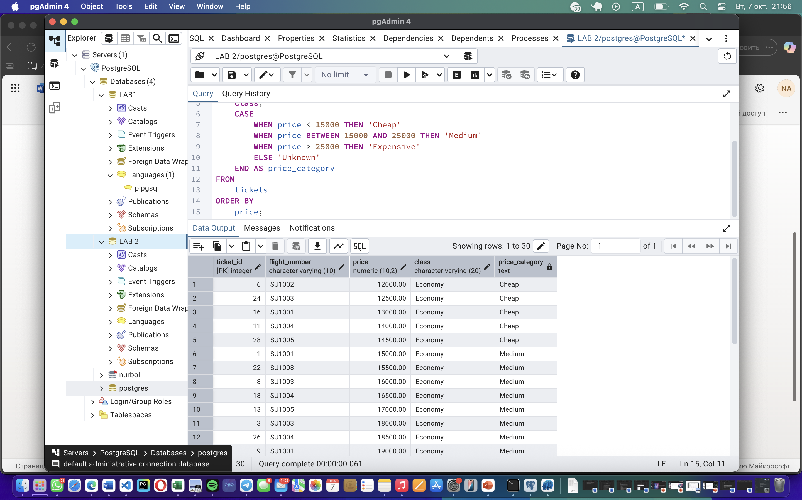

Task 9:

SELECT

airline_country,

COUNT(airline_name) AS number_of_airlines

FROM

airline

GROUP BY

airline_country

ORDER BY

number_of_airlines DESC;

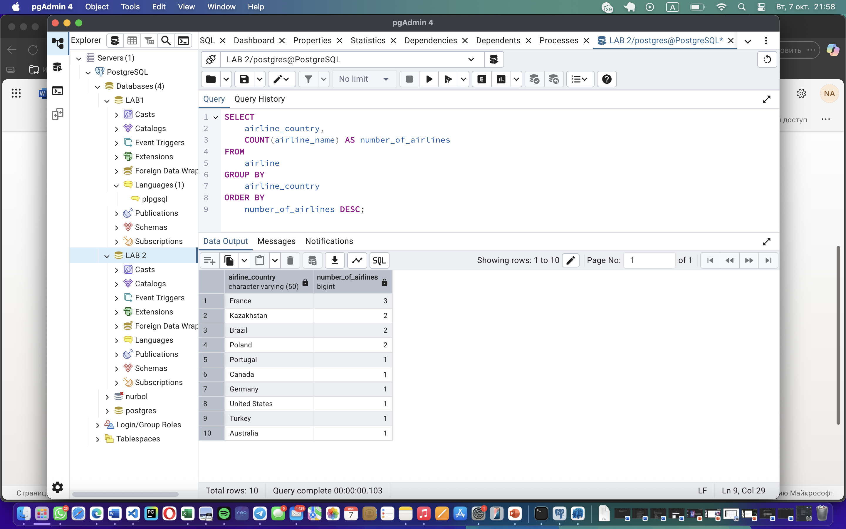

Task 10:

SELECT

flight_id,

sch_departure_time AS scheduled_departure,

sch_arrival_time AS scheduled_arrival,

act_departure_time AS actual_departure,

act_arrival_time AS actual_arrival,

(act_arrival_time - sch_arrival_time) AS arrival_delay,

EXTRACT(EPOCH FROM (act_arrival_time - sch_arrival_time))/60 AS delay_minutes

FROM

flights

WHERE

act_arrival_time > sch_arrival_time

ORDER BY

delay_minutes DESC;

